Class 12
CHAPTER -STRESS
PSYCHOLOGY
STRESS is a pattern of responses an organism makes to stimulus event that disturbs the equilibrium and exceeds a person’s ability to cope .
Or
Our response to events that disrupt threaten to disrupt, our physical or psychological functioning .
Stressors are events or situations in our environment that cause stress .

stress

EUSTRESS DISTRESS( it causes our body
(good for individuals ) wear and tear)
- Stress has derived from Latin word ‘strictus’ meaning tight and narrow . The reaction to external stressors is called strain.
- Stress has both cause and effects , may cause confusion.
- It is a dynamic mental / cognitive state .
- The perception of stress may vary from individual to individual as resources available to deal with it.
- The concept of stress under cognitive approach was given by LAZARUS and his colleagues:
An individual’s response to a stressful situation largely depends upon the perceived events and how they are interpreted or appraised .
He distinguished between two types of appraisal

PRIMARY APPRAISAL SECONDARY APPRAISAL
neutral in its consequences positive ,negative assessment of one’s coping
HARM ----- THREAT----- CHALLENGE abilities and resources to deal with the event .

THE ROLE OF COGNITIVE APPRAISAL
NO STRESS
HARMLESS
PRIMARY APPRAISAL
STIMULUS EVENT
THREATENINGGG

SECONDARY APPRAISAL

COPING MECHANISMS ARE THOUGHT TO BE ADEQUATE
COPING MECHANISMS ARE THOUGHT TO BE INADEQUATE

NO STRESS STRESS

- These appraisals are very subjective and depends on many factors such as
past experiences , controllable.

Types of stressors : environmental , psychological , social.

Dimensions : intensity , duration , complexity, predictability.
- These stressors result in variety of stress reactions which may be physiological , behavioural, emotional and cognitive .
- Symptoms of stress:
- Lack of concentration
- Memory loss
- Poor decision making
- Inconsistency
- Low self esteem
- Extreme mood swings
- Anxiety , worry , fear,
- Depression , difficulties with sleep and eating etc.

Types of stress -
ENVIRONMENTAL STRESS
- Surroundings that are unavoidable such as air pollution, crowding ,noise etc .
- Catastrophic events or disasters such as earth quake or floods .
PSYCHOLOGICAL STRESS
- Generate ourselves in our minds
- Are subjective and internal sources of stress
- Sources of psychological stress are – frustration , conflict , internal pressure , social pressure.
- Frustration :

- Conflict :

- Internal pressure:

- Social pressure:

SOCIAL STRESS
- Induced externally and result from our interaction with other people.
- Social events such as death , strained relationship ,etc
- It varies from person to person.
Eg : attending parties for one may be stressful and for others may be stress buster.

SOURCES OF STRESS

LIFE EVENTS HASSLES TRAUMATIC EVENTS
Eg: death of a close family Eg: noisy surroundings Eg: fire or train or
member , break up with friend . community , quarrelsome road accident ,earthquake
neighbours .

EFFECTS OF STRESS ON PSYCHOLOGICAL FUNCTIONING AND HEALTH
EFFECTS

EMOTIONAL COGNITIVE
- mood swing, mental overload
- Alienate them from family and friends loose ability to make sound decision
- Experience dec in level of confidence , poor concentration and reduction
- feeling of anxiety and depression reduced short term memory
- inc physical tension etc .

PHYSIOLOGICAL BEHAVIOURAL
- Inc in certain hormones which produces mark eating less nutritional food ,
changes in heart rate, blood pressure etc taking of stimulants such as caffeine,
- can damage body for long run , cigarettes, alcohol and other drugs
- slowing down of digestive system. Disturbed sleep patterns , reduced work performance

STRESS AND HEALTH
When stress is prolonged , it effects physical health and impairs psychological functioning . people may experience exhaustion and attitude problems .
Physical exhaustion is seen in the sign of chronic fatigue ,weakness and low energy . mental exhaustion can be seen through irritability , anxiety, feeling of helplessness and hopelessness .
This state of physical, emotional, and psychological exhaustion is known as burnout .
GAS : GENERAL ADAPTATION SYNDROME
Hans Selye in 1976 gave the concept of GAS which consists of three stages ,it act as a response to stress. ALARM REACTION: body prepares itself for immediate action , arousal of sympathetic nervous system releases hormones that help our body to meet threats or dangers.(ready to fight or flight)
RESISTANCE REACTION: If stress is prolonged , however the resistance stage begins. Here arousal is lower than earlier stage. Tries to cope with stress as through confrontation.
EXAUSTION STAGE: during this stage our capacity to resist is depleted , and our susceptibility to illness increases . May result in death or other heart related diseases.

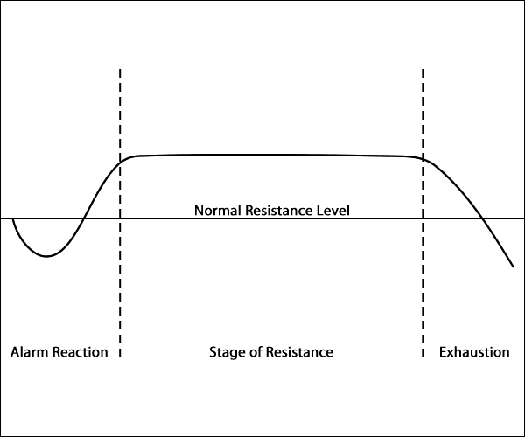
GAS MODEL OF STRESS BY HANS SELYE’S

COPING WITH STRESS
- Coping is a dynamic situation – specific reaction to stress . It is a set of concrete responses to stressful situation or events that are intended to resolve the problem and reduce stress .
In recent years the conviction has grown that it is how we cope with stress and not the stress one experiences that influences our psychological well-being ,social functioning and health .COPING is a dynamic situation specific reaction to stress. It is a set of concrete responses to stressful situations or events that are intended to resolve the problem and reduce stress. The way we cope with stress often depends on rigid deep-seated beliefs, based on experience, Eg:- when caught in a traffic jam we feel angry, because we believe that the traffic should move faster .To manage stress we often need to reassess the way we think and learn coping strategies. People who cope poorly with stress have an impaired immune response and diminished activity of natural killer cells. Individuals show consistent individual differences in the coping strategies they use to handle stressful situations. These can include both overt and covert activities. The three coping strategies given by the psychologist ENDLER & PARKER are:-

1. TASK-ORIENTED STRATEGY:-
This involves obtaining information about the stressful situation and about alternative courses of action and their probable outcome; it also involves deciding priorities and acting so as to deal directly with the stressful situation For example ,schedule my time better, or think about how I have solved similar problems.

2. ORIENTED MOTION STRATEGY:-
This can involve efforts to maintain hope and to control ones emotions; it can also involve venting feeling of anger and frustration ,or deciding that nothing can be done to change things .For eg :-tell myself that it is not really happening to me, or worry about what I am going to do.

3. AVOIDANCE-ORIENTED STRATEGY:-
This involves denying or minimising the seriousness of the situation; it also involves conscious suppression of stressful thoughts and their replacement by self protective thoughts .Example of this are watching TV, phone up a friend ,or try to be with other people.
LAZARUS&FOLKMAN has conceptualized coping as a dynamic process rather than an individual trait. Coping refers to constantly changing cognitive and behavioural efforts to master, reduce or tolerate the internal or external demands that are created by the stressful transaction .Coping serves to allow the individual to manage or alter a problem and regulate the emotional response to that problem. According to them coping response can be divided into two types of responses PROBLEM FOCUSED &EMOTIONAL FOCUSED.
Problem focused strategies attack the problem itself, with behaviours designed to gain information to alter the event, and to alter beliefs and commitments. They increase the persons awareness level of knowledge, and range of behavioural and cognitive coping options. They can act to reduce the threat value of the event .For eg:- I made a plan of action and followed it.
STRESS MANAGEMENT TECHNIQUES:
RELAXATION TECHNIQUES

MEDITATION TECHNIQUES

BIOFEEDBACK

CREATIVE VISUALISATION

EXERCISE

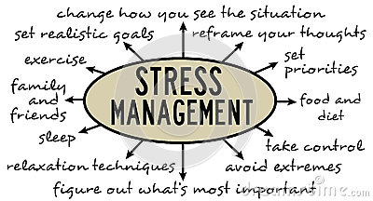
PROMOTING POSITIVE HEALTH AND WELLBEING
- Positive health and well- being comes through balanced diet ,exercise , positive attitude , optimistic thinking and social support . There is also a need for overall harmonious conditions in society. We must avoid taking unhealthy escape routes of smoking , alcohol, drugs and other harmful behaviours.
- STRESS RESISTANCE PERSONALITY:
- Kobasa have shown that people with high level of stress but low level of illness share three characteristics which are referred to as the personality traits . of hardiness.
- It consists of three Cs’ – commitment , control and challenge .
- Hardiness is a set of beliefs about oneself , the world and how they interact.
- Takes shape as a sense of personal commitment to what you are doing , a sense of control over your life and feeling of challenge

- LIFE SKILLS :

- abilities for adaptive and positive behaviuor that enables individuals to deal effectively with the demands and challenges of every day.
- How well we are prepared to deal with and counterbalance every day demands and maintain equilibrium in life.

- ASSERTIVENESS
- Behaviour or skills that help to communicate , clearly and confident, our feelings , thoughts ,needs, wants.
- Ability to say NO to a request or express emotions of anger , love etc openly.
- People high on this are confident, and have high self esteem .

- TIME MANAGEMENT
- Learn to plan time which can help to deal with pressure .
- Spend time doing things that you value or which will help you to achieve goal.
- Being realistic about what you know and that you must do it within certain period of time .
- RATIONAL THINKING
- Stress may result from distorted thinking.
- When we are in stress, we mostly attend to negative thoughts which affects our perception of present and future.
- Challenge negative thoughts and replace it by positive .
- SELF CARE
- Its important to keep ourselves healthy and relaxed we are better prepared physically and emotionally to tackle the stresses of everyday life .
- Most relaxed Breathing is slow stomach centred .
- OVERCOMING UNHELPFUL HABBITS
- Unhelpful habits such as perfectionism , avoidance , procrastination etc are strategies.
- Positive health .
- Positive health and wellbeing come through balanced diet , exercise ,positive attitude ,positive optimistic thinking ,and social support .
- There is a need of total harmonious conditions in society.
- We must avoid taking unhealthy escape routes of smoking , alcohol , drugs and other harmful behaviours.

